______________________________________________________________________________________________________________

SECTION 1: Identification of the substance/mixture and of the company/undertaking

  - Product identifier
Product name | : | Chromoionophore III
Catalogue number | : | SP-I-0023
CAS No. | : | 149683-18-1
Company | : | Eaglenos
UFI | : | -

  - Relevant identified uses of the substance or mixture and uses advised against
Relevant identified uses | ： | Laboratory chemicals, Manufacture of substances

  - Details of the supplier of the safety data sheet
Eaglenos Sciences, Inc. DBA
Address (CN): 73 Tanmi Road, BLDG B2-2, Nanjing, Jiangsu 210044
Address (US): 3928 Varsity Dr. Ann Arbor, MI, US 48108
Tel: +86-400-019-0069(CN)
Tel: +1-(888) 522-6398(US)

  - Emergency telephone number
Emergency telephone #: |  | +1- (888) 522-6398(English)

__________________________________________________________________________________

SECTION 2: Hazards identification

  - Classification of the substance or mixture

Classification according to Regulation (EC) No 1272/2008
Acute toxicity,oral,Category 4,H302
Skin corrosion/irritation,Category 2,H315
Serious eye damage/eye irritation,Category 2A,H319

For the Full text of H- and EUH-phrases mentioned in this Section: see SECTION 16.

  - Label elements
Labelling according to Regulation(EC) No 1272/2008
Hazard pictograms
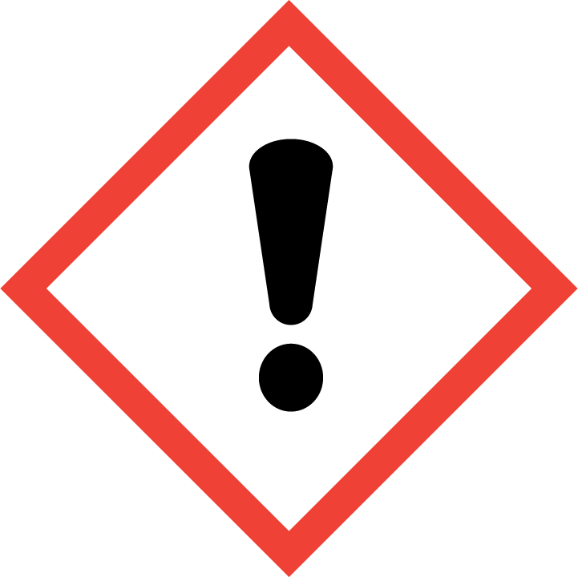

Signal word
Warning
Hazard statements
H302 Harmful if swallowed
H315 Causes skin irritation
H319 Causes serious eye irritation

Prevention Precautionary statements
P264 | Wash hands [and …] thoroughly after handling.
P270 | Do not eat, drink or smoke when using this product.
P280 | Wear protective gloves/protective clothing/eye protection/face protection.
Response Precautionary statement
P301+P317 | IF SWALLOWED: Get medical help.
P302+P352 | IF ON SKIN: wash with plenty of water/...
P305+P351+P338 | IF IN EYES: Rinse cautiously with water for several minutes. Remove contact lenses, if present and easy to do. Continue rinsing.
P321 | Specific treatment (see ... on this label).
P330 | Rinse mouth.
P332+P317 | If skin irritation occurs: Get medical help.
P337+P317 | If eye irritation persists: Get medical help.
P362 | Take off contaminated clothing.
Storage Precautionary statements
Disposal Precautionary statements
P501 | Dispose of contents/container to ...
Supplemental Hazard information

None.

  - Other hazards
This substance is not considered to be persistent, bioaccumulating and toxic (PBT). This substance is not considered to having endocrine disrupting properties.

__________________________________________________________________________________
SECTION 3: Composition/information on ingredients

  - Substances

Product name | Chromoionophore III
CAS No | 149683-18-1
Formulae | C38H55N3O
Molecular Weight | 569.86
Concentration | -
Specific concentration limit | -
M-factor | -
Acute toxicity estimate | -

  - Mixtures

None
_

SECTION 4: First aid measures

4.1 Description of first aid measures

General information

Consult a physician. Show this safety data sheet to the doctor in attendance.

Following inhalation

Remove victim to fresh air. If not breathing, give artificial respiration, better not to mouth-to-mouth. If breathing is difficult, give oxygen. Consult medical personnel.

Following skin contact
Wash material off the skin with plenty of soap and water. If redness, itching or a burning
sensation develops, get medical attention.

Following eye contact
Immediately flush with plenty of water for at least 15 minutes. If redness, itching or a burning sensation develops, have eyes examined and treated by medical personnel.

Following ingestion

Provided the patient is conscious, wash out mouth with water. Vomiting should only be induced under the direction of a physician or a poison control centre.

4.2 Most important symptoms and effects, both acute and delayed

The most important known symptoms and effects are described in the labelling (see section 2.2) and/or in section 11.

4.3 Indication of any immediate medical attention and special treatment needed

No data available
___________________________________________________________________________________
SECTION 5: Firefighting measures

5.1 Extinguishing media
Suitable extinguishing media

Use extinguishing media appropriate, such as water spray, alcohol-resistant foam, dry chemical powder or carbon dioxide, for surrounding fire.

Unsuitable extinguishing media

Avoid high pressure media which could cause the formation of a potentially explosible dust.

5.2 Special hazards arising from the substance or mixture

Emit toxic fumes under fire conditions, such as carbon oxides, Nitrogen oxides (NOx);
If substance is an organic solid, fine dust dispersed in air in sufficient concentrations in the presence of an ignition source is a potential for a dust explosion hazard.

5.3 Advice for fire-fighters
Keep containers cool with water spray and on special protective equipment for firefighters, such as boots, overalls, gloves, eye and face protection and breathing apparatus.

5.4 Further information

No data available
___________________________________________________________________________________

SECTION 6: Accidental release measures

6.1 Personal precautions, protective equipment and emergency procedures

For non-emergency personnel
- the wearing of suitable protective equipment (including personal protective equipment referred to under Section 8 of the safety data sheet)to prevent any contamination of skin, eyes and personal clothing;
- removal of ignitionsources, provision of sufficient ventilation, control of dust; and
- Emergency procedures such as the need to evacuate the danger area or to consult an expert.
For emergency responders

Wear positive pressure self-contained breathing apparatus, wear anti - toxic, anti - static, wear chemical anti - penetration gloves.

  - Environmental precautions

Prevent entry to sewers and public waters.

  - Methods and material for containment and cleaning up
For containment
Contain solid spills with appropriate barriers and prevent migration and entry into sewers or streams.

For cleaning up
Clean up spills immediately and dispose of waste safely. Recover the product by vacuuming, shovelling or sweeping. Transfer spilled material to a suitable container for disposal. Contact competent authorities after a spill.

  - Reference to other sections
See Section 8 for exposure controls and personal protection and Section 13 for disposal considerations.
___________________________________________________________________________________

SECTION 7: Handling and storage
7.1 Precautions for safe handling

- Take measures to prevent the build-up of electrostatic charge.
- Provide appropriate exhaust ventilation at places where dust is formed.
- Not to eat, drink, smoke in work areas.
- To wash hands after use.
- To remove contaminated clothing and protective equipment before entering eating areas.
For precautions see section 2.2.

7.2 Conditions for safe storage, including any incompatibilities
Technical measures and storage conditions

- Store away from incompatible substances.
- Keep tightly closed and store in a dry place and well-ventilated place.
- Controlled 2~8 ^{º}C.
7.3 Specific end uses

Apart from the uses mentioned in section 1.2 no other specific uses are stipulated.
___________________________________________________________________________________

SECTION 8: Exposure controls/personal protection

  - Control parameters

Components with workplace control parameters

  - Exposure controls

Appropriate engineering controls

- Suitable eye/body wash equipment should be available in the vicinity of any potential exposure.
- Ensure adequate ventilation, especially in confined areas.
- Use explosion-proof electrical appliances, ventilation, lighting and other equipment.
- Set up emergency evacuation routes and necessary evacuation zones.
Personal protective equipment

Eye / Face protection

Use equipment for eye/faceprotection tested and approved under appropriate government standards such as NIOSH (US) or EN 166(EU).

Skin protection

- Wear suitable protective clothing.
- Handle with gloves.Gloves must be inspected prior to use. Use proper gloves removal technique (without touching glove`s outer surface) to avoid skin contact with this product. Dispose of contaminated gloves after use in accordance with applicable laws and good laboratory practices. Wash and dry hands.
- The selected protective gloves have to satisfy the specifications of Regulation(EU 2016/425)and the standard EN 374 derived from it.
- This recommendation is advisory only and must be evaluated by an industrial hygienist and safety officer familiar with the specific situation of anticipated use by our customers. It should not be construed as offering an approval for any specific use scenario.
Body protection

Choose body protection in relation to its type, to the concentration and amount of dangerous substance, and to the specific work-place,the type of protective equipment must be selected according to the concentration and amount of the dangerous substance at the specific workplace.

Respiratory protection
Respiratory protection is not required. Where protection from nuisance levels of dusts are desired, use type N95(US)or type P1(EN143) dust masks.use respirators and components tested and approved under appropriate gpvernment standards such as NIOSH(US)or CEN(EU).

Control of environmental exposure

No special environmental precautions required.
_________________________________________________________________________________

SECTION 9: Physical and chemical properties

9.1 Information on basic physical and chemical properties

Physical state | Solid
Colour | Purple
Odour | Weak odor
Particle characteristics (solids) | The substance is not in nanoform
Odour threshold | No data available
pH | No data available
Melting point/freezing point | No data available
Initial boiling point/boiling range | No data available
Flash point | No data available
Evaporation rate | No data available
Flammability (gases, liquids and solids) | No data available
Upper explosive limits | No data available
Lower explosive limits | No data available
Vapour pressure | No data available
Vapour density | No data available
Relative density | No data available
Water solubility | No data available
Partition coefficient : n-octanol/water | No data available
Auto-ignition temperature | The substance is not classified as self heating
Decomposition temperature | No data available
Kinematic viscosity | No data available
Explosive properties | No data available
Oxidizing properties | No data available

9.2 Other information

No data available
_________________________________________________________________

SECTION 10: Stability and reactivity
10.1 Reactivity

No data available.

10.2 Chemical stability

The substance is stable under normal ambient and anticipated storage and handling conditions of temperature and pressure.

10.3 Possibility of hazardous reactions
No data available.

10.4 Conditions to avoid

Direct sunlight, extremely high temperatures, hygroscopic and incompatible materials.

10.5 Incompatible materials

Strong acids, strong bases, strong oxidizers.

10.6 Hazardous decomposition products

Hazardous decomposition products formed under fire conditions.--Carbon monoxide, Carbon dioxide, Nitrogen oxides and others.

No hazardous decomposition products are produced under normal storage and use conditions
___________________________________________________________________________________

SECTION 11: Toxicological information

11.1 Information on toxicological effects
Acute toxicity | No data available
Skin corrosion/irritation | No data available
Serious eye damage/eye irritation | No data available
Respiratory or skin sensitization | No data available
Germ cell mutagenicity | No data available
Carcinogenicity | IARC: no componment of this product present at levels greater than or equal to 0.1%is identified as probable, possible or confirmed human carcinogen by IARC.
Reproductive toxicity | No data available
Specific Target Organ Toxicity (Single Exposure) | No data available
Specific Target Organ Toxicity (Repeated Exposure) | No data available
Aspiration hazard | No data available
Chronic Symptoms | No data available

To the best of our knowledge, the chemical, physical, and toxicological properties have not been thoroughly investigated.
11.2 Information on other hazards
Endocrine disrupting properties

Substances that do not contain endocrine disrupting properties

Other information

No data available.

___________________________________________________________________________________
SECTION 12: Ecological information

12.1 Toxicity

No data available.

12.2 Persistence and degradability

No data available.

12.3 Bioaccumulative potential

No data available.

12.4 Mobility in soil

No data available.

12.5 Results of PBT and vPvB assessment

This substance/mixture contains no components considered to be either persistent, bioaccumulative and toxic (PBT), or very persistent and very bioaccumulative (vPvB) at levels of 0.1% or higher.

12.6 Endocrine disrupting properties

This substance/mixture contains no components considered to be endocrine disrupting properties.

_____________________________________

SECTION 13: Disposal considerations
13.1 Waste treatment methods

- Dispose of contents/container in accordance with local, regional, national, and internationalregulations. Avoid release to the environment.
- Contaminated packaging dispose of as unused product.
___________________________________________________________________________________
SECTION 14: Transport information
14.1 UN number
- | - | -
14.2 UN Proper shipping name
ADR/RID: Not dangerous goods
IMDG: Not dangerous goods
IATA: Not dangerous goods
14.3 Transport hazard class(es)
ADR/RID: - | IMDG: - | IATA: -
14.4 Packing group
ADR/RID:- | IMDG: - | IATA: -
14.5 Environmental hazards
ADR/RID:NO | IMDG: NO | IATA: NO

14.6 Special precautions for user

No data available.

14.7 Transport in bulk according to Annex Ⅱ of Marpol and IBC Code

Not Applicable
_______________________________________________________________________________

SECTION 15: Regulatory information

15.1 Safety, health and environmental regulations/legislation specific for the substance or mixture

This safety datasheet complies with the requirements of Regulation (EU) 2020/878.

15.2 Chemical Safety Assessment

For this product a chemical safety assessment was not carried out.
___________________________________________________________________________________

SECTION 16: Other information

16.1 Full text of H-Statements referred to under sections 2 and 3

H302 Harmful if swallowed
H315 Causes skin irritation
H319 Causes serious eye irritation

16.2 Further information

The information in this SDS was obtained from sources which we believe are reliable. However, the information is provided without any warranty, express or implied, regarding its correctness. The conditions or methods of handling, storage, use or disposal of the product are beyond our control and may be beyond our knowledge. For this and other reasons, we do not assume responsibility and expressly disclaim liability for loss, damage or expense arising out of or in any way connected with the handling, storage, use or disposal of the product. This SDS was prepared and is to be used only for this product. If the product is used as a component in another product, this SDS information may not be applicable.

